
Assessment Cover Page
Student Full Name | Silvia Elena Solano Marchini
Student Number | 2026362
Module Title | Strategic Thinking
Assessment Title | CA 1 – Capstone Project Proposal
Lecturer/Supervisor | Taufique Ahmed
Assessment Due Date | 25.10.2026
Date of Submission | 23.20.2026

Use of AI Tools

I acknowledge using Grammarly to check my orthography for this project.

Declaration
By submitting this assessment, I confirm that I have read the CCT policy on academic misconduct and understand the implications of submitting work that is not my own or does not appropriately reference material taken from a third party or other source.
I declare it to be my own work and that all material from third parties has been appropriately referenced.
I further confirm that this work has not previously been submitted for assessment by myself or someone else in CCT College Dublin or any other higher education institution.

Contents

Project Title 3
Introduction 3
Brief Overview 3
Business Context, Relevance and Significance 3
Problem 4
Aim and Objective 4
Aim 4
Specific Objectives 4
Business Hypothesis 5
Scope 5
In Scope 5
Out of Scope 5
Methodology 6
Proposed data analytics methods 6
Technologies and Tools 6
System Architecture 6
High-Level Architecture Diagram 6
Data Sources 8
Type of Data Sources 8
Approx. Amount of Data Required 9
Expected Deliverables 9
Project Timeline 9
Ethical and Legal Considerations 10
References 10

Project Title

Predicting Consumer Adaptation of Digital Credit Across European Markets in Fintech vs Traditional Banking.

Introduction

Brief Overview

The project demonstrates the shifting dynamics of consumer credit in Europe, contrasting traditional banking with Fintech platforms. Using a predictive model, it examines consumer trends in digital credit channels and the European macroeconomic environment, using data from Eurostats, the European Central Bank and the DESI index.

Business Context, Relevance and Significance

Historically, banks have dominated the financial industry; therefore, customers are used to going through a different process in person and having some kind of underwriting with them.
Meanwhile, the industry of Fintech come to change the panorama of the majority of the process with methodologies more agile than the usual, offering digital and faster onboarding, instant credit, transaction on real time, etc. While macroeconomic conditions are changing and have a big impact on consumer behaviour, giving more options to people to choose between digital credit and traditional bank channels.

Additionally, the fluctuation in interest rates, rising inflation and diverse levels of households between the Member States of the European Union are creating an unpredictable credit environment.

Problem

The lack of predictive capability in both the Fintech and bank industries regarding customer channel migration between credit channels across the macroeconomic European markets.

The business impact of the problem would be that the inability to forecast channel adaptation leads to customer churn in banks and higher CAC in Fintech.

Aim and Objective

Aim

The overall project aim is to create a predictive model to forecast consumer adaptation to digital credit in the Fintech versus Bank industry across the European market, taking into consideration the macroeconomic and demographic development.

Specific Objectives

- Integrate different datasets from Eurostat and the European Central Bank, focusing on macroeconomic and demographic data to standardise data from European countries.
- Train and evaluate a supervised Machine Learning model to predict consumer credit selection.
- Apply techniques to quantify channel migration and predictive a model to provide strategy recommendations for both the Fintech and Bank industry.

Business Hypothesis

If consumer channel migration towards digital credit can be predicted using macroeconomic and digital indicators, then Fintech will reduce CAC and the bank sector will identify the customer friction points.

Scope

In Scope

- Contrast between member states of Europe with different levels of digital infrastructure and banking industry.
- Integrate datasets from Eurostat and the European Central Bank on macroeconomic subjects.
- Consumer retail credit.
- Data standardisation in Python with a supervised Machine Learning model using metrics.
- Recommendations for the CAC sector and retention of customer in traditional banks.

Out of Scope
- Commercial sector in macroeconomic and credit topics.
- Non-European markets.
- Information with specific proprietary Banking Data.

Methodology

Proposed data analytics methods

- Merge and extraction of multi dataset about macroeconomic, demographic and digital metrics.
- Create an analysis correlated with the EDA to identify the adaptation across Europe.
- Clean and process the data.
- Train a supervisor Machine Learning through economics settings, handling non-linear feature interactions.
- Classify the performance of the dataset.
- Model the predictions to give recommendations about the migration.

Technologies and Tools

- Python – Jupyter Notebook: Program where the code would be developed.
- GitHub: program with a collaborative environment.
- Python: where we can develop a dashboard.

System Architecture

The dataset will be taken from Eurostats, the European Central Bank and DESI, and the information we can find will be about macroeconomic, digital usage and demographic situation. Then, the data will be cleaned and prepared for tabulation. Besides, develop a supervised classification to evaluate metric trade-offs, and the last point would be to translate the algorithmic in recommendations for business (CAC for Fintech and traditional banking).

High-Level Architecture Diagram

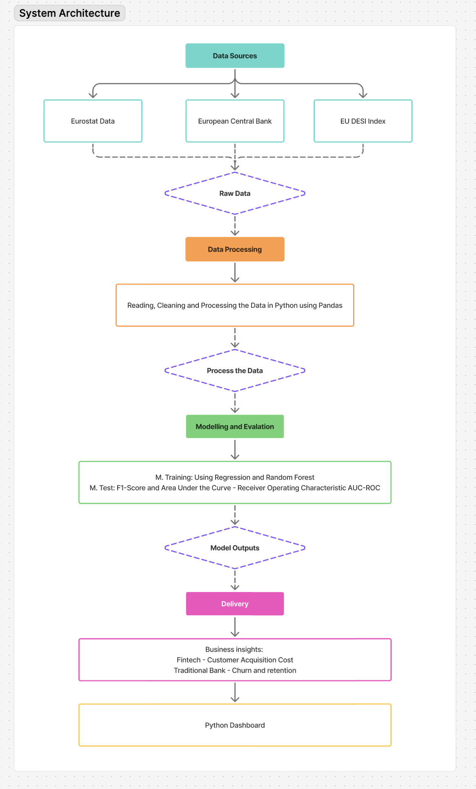
The diagram was created using Figma.

- Data Sources: All the different websites that are used in the project, with topics such as digital usage, demographic and macroeconomic datasets.
- Data Processing: The step where the dataset needs to be cleaned, read, and processed in Python for the unification of the data.
- Model Outputs: Using supervised Machine Learning to classify, evaluate, and interpret the model.
- Delivery + Python Dashboard: Recommendations for Fintech (CAC) and traditional banks (Churn and retention).

Data Sources

To create a predictive framework for the European market, focus on credit channel adaptation.

Type of Data Sources

Eurostats (European Statistical Recovery and Microdata Databases)
- Internet banking Activities
- ([isoc_ci_ac_i] Individuals - internet activities, no date)
- Digital Credit/Loan Request ([isoc_ec_ifi] Financial activities over the internet (2016-2019), no date)
- Household Financial Vulnerability ([ilc_mdes03] Inability to afford a meal with meat, chicken, fish (or vegetarian equivalent) every second day, no date)

ECB Data Portal (European Central Bank)
- MFI Interest Rates Statistics (MIR)(Homepage | ECB Data Portal, no date)
- Payment Statistics (PAY) (Homepage | ECB Data Portal, no date)

Digital Economy and Society Index – DESI (European Commission)
- Digital Skills, Digital Infrastructure and Integration of Digital Technology (desi-data) (Digital Decade DESI visualisation tool, no date)

Approx. Amount of Data Required

The geographical scope will consist of 6 EU Member States, representing the contrast between digital and traditional banks. Using data from the ECB, Eurostats and DESI to link the relationship between the central bank, fintech and adaptation in credit.

According to(Keeping cash across Europe: Which countries use the most?, 07:00:25 +02:00) the countries that are used in this project would be Spain, Italy and Slovenia as examples of traditional banks. Meanwhile, the countries focused on Fintech would be Ireland, the Netherlands and Germany.

The estimation of the data used for the project (ECB, Eurostats and DESI Index) are open data from the European Union.

Expected Deliverables

- Data Source: Clean, merge and process the data from Eurostats, ECB and DESI Index.
- EDA Report: Statistical visualisations of the insights about the customer channel migration between Fintech (CAC) and traditional banks.

Project Timeline

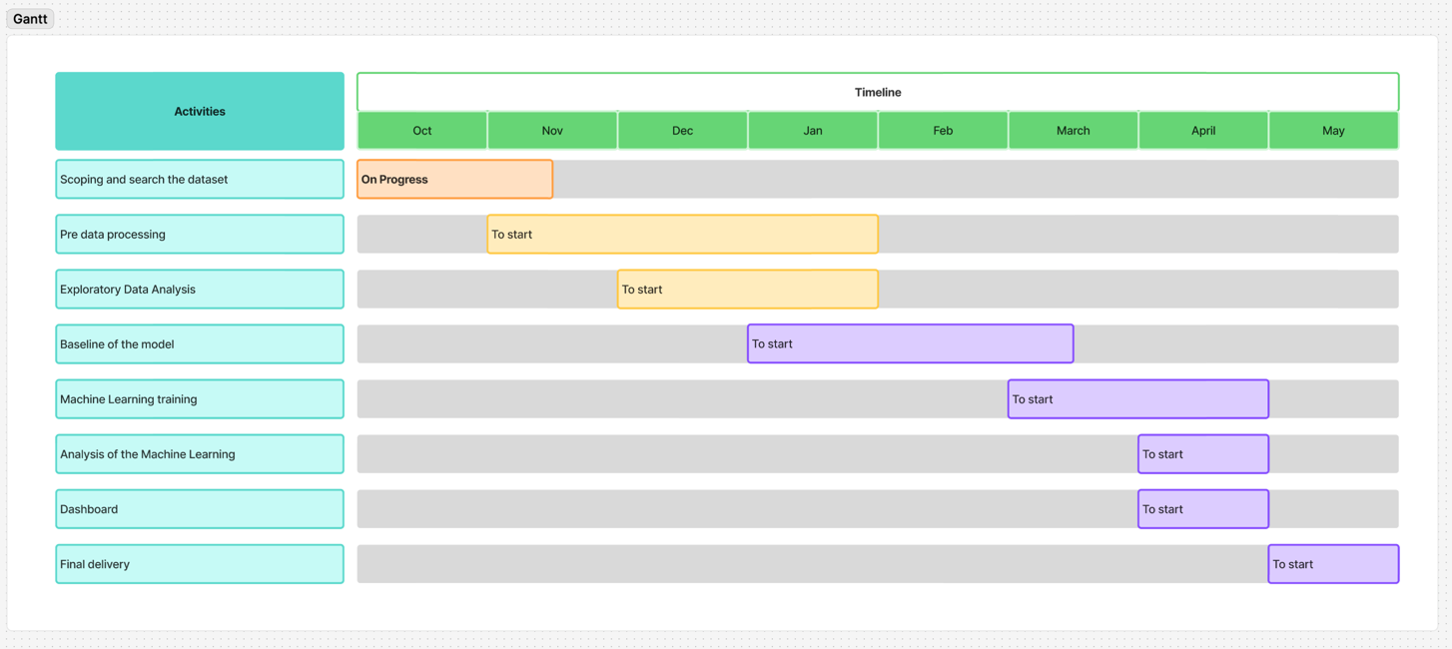

The Gantt schedule was created using Figma

Ethical and Legal Considerations

- Data Protection: The project uses public data from Eurostats, the ECB and the DESI index, a European open-data source, with permission to use those data for research and analysis.
- GitHub: Using the program to control the development, reproducibility, and data integrity for academic focus.

References
Digital Decade DESI visualisation tool (no date). Available at: https://digital-decade-desi.digital-strategy.ec.europa.eu/datasets/desi/metadata (Accessed: 15 October 2026).
Homepage | ECB Data Portal (no date). Available at: https://data.ecb.europa.eu/ (Accessed: 15 October 2026).
[ilc_mdes03] Inability to afford a meal with meat, chicken, fish (or vegetarian equivalent) every second day (no date). Available at: https://ec.europa.eu/eurostat/databrowser/view/ilc_mdes03/default/table?lang=en (Accessed: 15 October 2026).
[isoc_ci_ac_i] Individuals - internet activities (no date). Available at: https://ec.europa.eu/eurostat/databrowser/view/isoc_ci_ac_i/default/table?lang=en (Accessed: 15 October 2026).
[isoc_ec_ifi] Financial activities over the internet (2016-2019) (no date). Available at: https://ec.europa.eu/eurostat/databrowser/view/isoc_ec_ifi/default/table?lang=en (Accessed: 15 October 2026).
Keeping cash across Europe: Which countries use the most? (07:00:25 +02:00) euronews. Available at: https://www.euronews.com/2025/10/05/keeping-cash-across-europe-which-countries-use-the-most (Accessed: 15 October 2026).

Use of Artificial Intelligence
This assessment applies the AI Fluency Framework — four interconnected competencies for effective, efficient, ethical and safe AI use. Your engagement with AI will be reviewed across all four dimensions:

Delegation  Setting goals and deciding whether, when and how to engage with AI. | Description  Effectively describing goals to prompt useful AI behaviours and outputs.
Discernment  Accurately assessing the usefulness of AI outputs and behaviours. | Diligence  Taking responsibility for what we do with AI and how we do it.

AI tools may be used in this assessment. Your use of AI will be assessed across the four ‘D’ competencies of the AI Fluency Framework.
Please see below. Note that for Software Development Fundamentals you are required to include an Appendix to show how you used AI. A sample has been provided.

AI Declaration using the AI Fluency Framework
For use in assessment briefs and student submissions. Lecturers complete the Lecturer Expectations column per assessment; students complete the Student Response column.

AI competence | Reflective prompts (to students) | Lecturer expectations | Student response
Delegation  Deciding whether & when to use AI | Identify the specific tasks in this assessment where you chose to use AI, and explain your reasoning. Where did AI add value? Where did you decide not to use it, and why? | You may use AI to support your learning and development of the application. Clearly identify where you used AI and where you completed the work independently. | Grammarly check the orthography of the completely document, I decided to use it because I know that I could have too many mistakes.
Description  How you prompted the AI | Include the exact prompts you used in your appendix (recorded on the AI Tools declaration). Reflect on how you communicated your goals to the AI — did you need to iterate or refine your prompts to get useful output? | You must provide the exact prompts and relevant AI outputs used during the development of your application. | I just did a document in Grammarly when I had finished to write the project.
Discernment  Evaluating what the AI produced | In your reflection, critically evaluate the AI output: what did you accept, modify, or reject — and why? Assess accuracy, relevance, and quality. You are responsible for verifying all AI-generated content before submitting. | You are responsible for checking, testing and understanding any AI-generated code or suggestions before using them in your work. | I accepted all the orthography modify that the program suggested.
Diligence  Responsibility for your AI use | Declare all AI tools used and cite them here. Briefly outline how you considered data protection, copyright, and ethical responsibilities when choosing what to input into any AI system. Unauthorised use is subject to CCT disciplinary procedures. | Declare all AI tools used. Do not enter personal, confidential or sensitive information into AI tools. Any external sources used should be appropriately referenced. | Grammarly

Adapted from the AI Fluency Framework (Dakan, Feller, Anthropic, 2025).

Appendix

